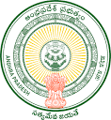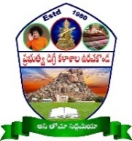**GOVERNMENT DEGREE COLLEGE**

**URAVAKONDA - 515 812**

(Accredited by NAAC with B Grade)

Affiliated to S K. University, Ananthapuramu

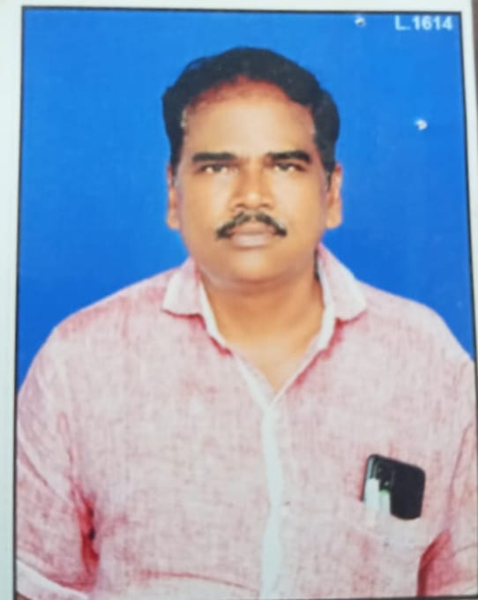

**PERSONAL PROFILE**

**S.NARAYANA SWAMY**

**Lecturer in English,**

Photo

**Govt.Degree College, Uravakonda**

**email: @gmail.com**

**Educational Qualifications:**

M.A.(ENG).,

**Professional Experience:**

25 years as DL in English (02-07-1997 to till to date)

* SSBN Degree College (A), Anantapuramu (From 02.07.01997 to 08-10-2021)
* Govt Degree College, Uravakonda (From 09-10-2021 to till to date)

**Academic Development: (RC, OC, FDP, TOT, MOOCS, Training programmes etc.)**

1. Attended the programme on “Indian Ethics in Night of the Scorpion,” organized by Sri Krishnadevaraya University, Anantapuramu from 03.009.2001 to 23.09.2001.
2. Attended the programme on “Listening and Speaking Skills,” organized by SSBN Degree College (A), Anantapuramu from 27.09.2005 to 01.10.2005.
3. Attended the programme on “English Language Teaching (ELT),” organized by Sri Krishnadevaraya University, Anantapuramu from 11.02.2006 to 03.03.2006.
4. Attended the programme on “Professional Ethics,” organized by Central University, Hyderabad from 17.07.2014 to 23.07.2014.

**Administrative Responsibilities:**

* Co-ordinator for UG Examinations and Dr. BRAOU
* NAAC - Member
* IQAC - Member
* Language Association - Member
* Press – Public Relationship Committee – Convenor
* Purchasing Committee – Member
* RUSA – Member
* Inclusive Canters – Member
* College Website - Convenor
* College Magazine Editorial Board - Member

**Achievements:**

**Research Publications:**

Nil